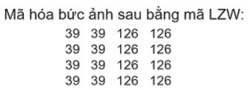

**Mã hoá**

|  |  |  |  |
| --- | --- | --- | --- |
| Input | Output | Codeword | Dictionary |
| 39 | 39 | 256 | 39 - 39 |
| 39 | 39 | 257 | 39 - 126 |
| 126 | 126 | 258 | 126 - 126 |
| 126 | 126 | 259 | 126 - 39 |
| 39 - 39 | 256 | 260 | 39 – 39 - 126 |
| 126 - 126 | 258 | 261 | 126 – 126 - 39 |
| 39 – 39 - 126 | 260 | 262 | 39 – 39 – 126 - 126 |
| 126 - 39 | 259 | 263 | 126 – 39 - 39 |
| 39 - 39 | 256 | 264 | 39 – 39 - 126 |
| 126 - 126 | 258 |  |  |